EC-231 Operating Systems
BS(CE)-2021
LAB REPORT # 4

Submitted By:
Reg. No. | Name
21-CE-009 | Huzaifa Shahbaz
Department of Computer Engineering
BS Computer Engineering Program
HITEC University Taxila
 | Presentation  (Format (0.5) + Title (0.5) +  Conclusion(1) + Procedure(2) + Objective(1)) | Calculation/Coding | Observation/ Program Results | Total
Total | 5 | 5 | 5 | 15
Obtained

___________________________
Lab Instructor.
Engr. Fasih Ahmad

Experiment #4
Implementation of Conditional Statements and Loops in Linux
Objective: The objectives of this lab are to familiarize students with shell programming and practice few problems related to 1: If-el1se statements 2:For loop 3:While loop in LINUX Ubuntu.

Software Used: 1. Ubuntu 2. gedit/vi(Text Editor)

Procedure: This lab has been designed to get even better insight of the shell programming. By the end of this lab we‘ll be able to solve more complex problems in Linux using shell.The details of few programming constructs to be used in the tasks are as follows: 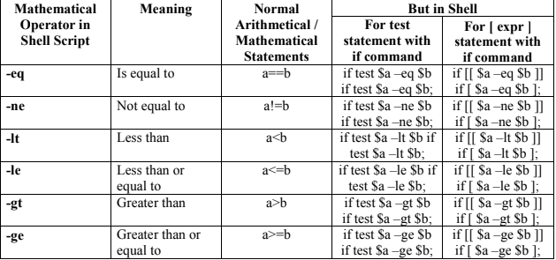 if statements : if condition then commands fi Example: Following script determine whether given argument number is positive. if test $1 -gt 0 then echo "$1 number is positive" fi Run it as follows: $ chmod 755 ispostive $./ ispostive 5 5 number is positive $./ispostive -45 Nothing is printed if else statements: ifcondition then commands else commands fi Example:
Following script determine whether given argument number is positive. $ cat>ispostive # # # Script to see whether argument is positive # number=10 if [ $number -eq 10 ]; then echo "Number is 10." Else echo "Number is not 10." Fi Run it as follows: $ chmod 755 ispostive $./ ispostive 5 Number is 10 Case...esac statement in shell: These are the statements in shell which replicates the switch case statements in c/c++ language. Syntax is as follows: #!/bin/bash # Example variable option="B" case "$option" in "A") echo "Option A selected" # Add commands to execute when option A is selected ;; "B") echo "Option B selected" # Add commands to execute when option B is selected ;; "C") echo "Option C selected" # Add commands to execute when option C is selected ;; *) echo "Invalid option" # Add commands to execute when none of the specified options match ;; esac While loop: while [ condition ] do command1 command2 .. .... commandN done Example: count=1 # While loop while [ $count -le 5 ]; do echo "Count: $count" count=$((count + 1)) done

Tasks
Task 1: Simulate suitable command/commands in gedit to input 2 numbers from user and display the greater number. CODE: 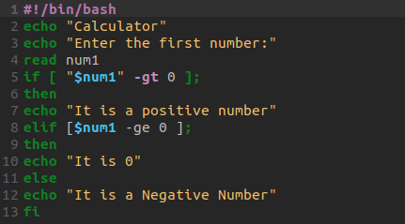
OUTPUT: 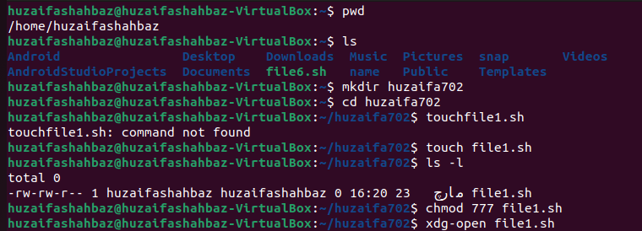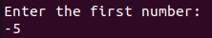

Task 2: Simulate suitable command/commands in gedit to input 2 numbers from user and make a simple calculator which should be capable of performing basic calculations i.e. addition, subtraction, multiplication, division by using if-else conditions. Display all possible outputs. CODE: 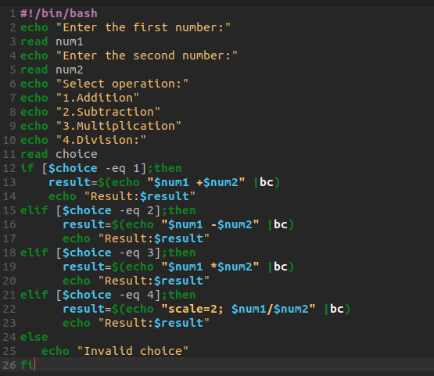 OUTPUT: 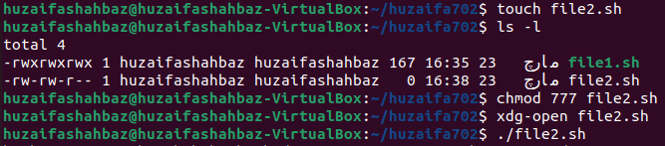 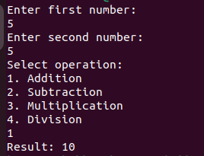
Task 3: Simulate suitable command/commands in gedit to input 2 numbers from user and make a simple calculator which should be capable of performing basic calculations i.e. addition, subtraction, multiplication, division by using switch-case statements. Display all possible outputs. CODE: 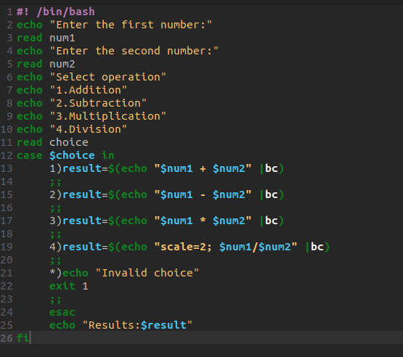 OUTPUT: 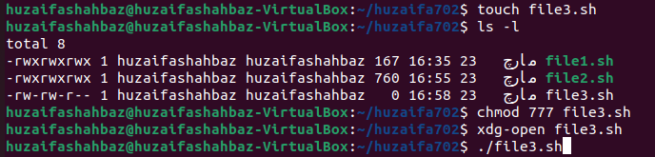 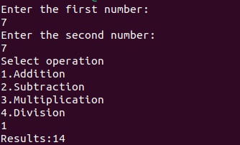 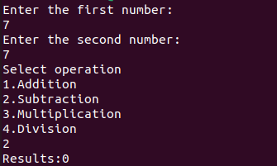 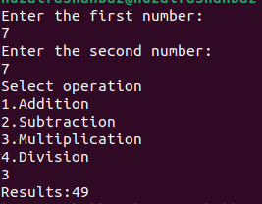
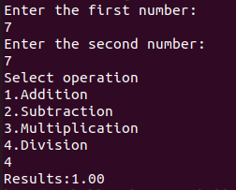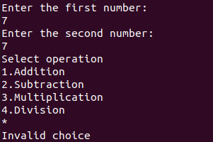
Task 4: Simulate suitable command/commands in gedit to print table of a user defined number. CODE: 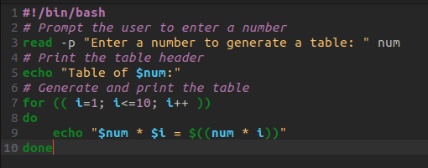 OUTPUT: 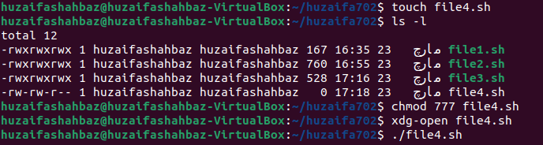 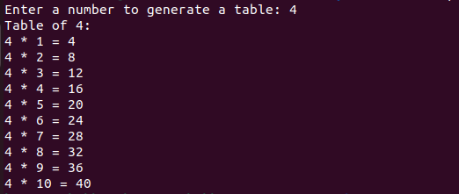
Task 5: Simulate suitable command/commands in gedit to check whether the user defined number is even or odd. CODE: 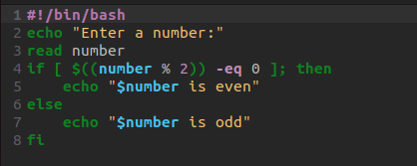 OUTPUT: 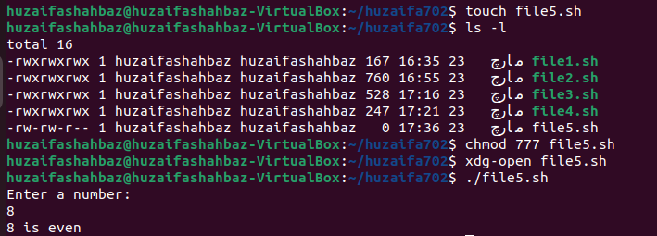
Conclusion: In conclusion, we had studied the conditions that is if statement, if-else statement, else-if statement and else statement. And we had studied the switch statement and also for loop and while loop. There functions and working in ubuntu operating system.

